John Mackay of Ravensden House
By Trevor Stewart
The extensive web of connections between various families living or serving in India during the late 1700’s and up to the Rebellion of 1857 is well documented. It is also known that the development of Bedford in the early years of the nineteenth century was very much influenced by many of these families returning to Britain searching for a good education for their children. There were soon to be famous names living in the town and who had intermarried during service in India, the Le Mesurier’s, the Huddleston’s, the Whiteside’s and the Macintosh’s to name but a few.
John Mackay of Scottish extraction was yet another when he brought the estate of Ravensden in 1818
But what of the Mackay story ?
John Mackay’s grandfather John born 1697, and his wife Grisselle Avis born 1689, were married at St. Martin In The Fields, London on 6th June 1720.
They had a son James born in London in 1732, baptised at St. Martin In The Fields, {who became the father of the Ravensden John}.
James married Betty or Betsy Barker at St. Martin In the Fields on 29th February 1756.
They had 6 children, 3 girls and 3 boys. John, was the youngest of these.
James Mackay born 29th May 1757, baptised at St. Martin In The Fields on 19th June 1757.
Elizabeth Mackay born 9th March 1759, baptised at St. Martin In The Fields, 19th March 1759.
Richard Mackay born 29th. October 1760, baptised 9th. November 1760 at St. James’s, Piccadilly.
Margaret Mackay born 5th January 1763, baptised 23rd January 1763 at St. James’s, Piccadilly.
Jane Mackay born 15th. May 1768, baptised 5th June 1768 at St. James’s, Piccadilly.
John Mackay born 26th. December 1769, baptised 21st January 1770 at St. James’s, Piccadilly.
{ Note the change from St. Martin’s to St. James’s Parish, which would appear to suggest that the family had moved to Piccadilly around 1760}.
Betty the mother of these children died in London in December 1789 and was buried at St. James’s {St. James’s Gardens} and James the father also died in London in 1795. Given his extensive connection with St. James’s, Piccadilly it is almost certain that he was also interred in the same place, possibly even the same grave.

James Mackay was an upholsterer based in Piccadilly. Further research reveals that at that time ‘’upholsterer’’ meant slightly more than it does at present. While that was the primary trade they were also what we would now know as designers and interior decorators and thus worked in many prestigious houses, for influential people and for members of the aristocracy.
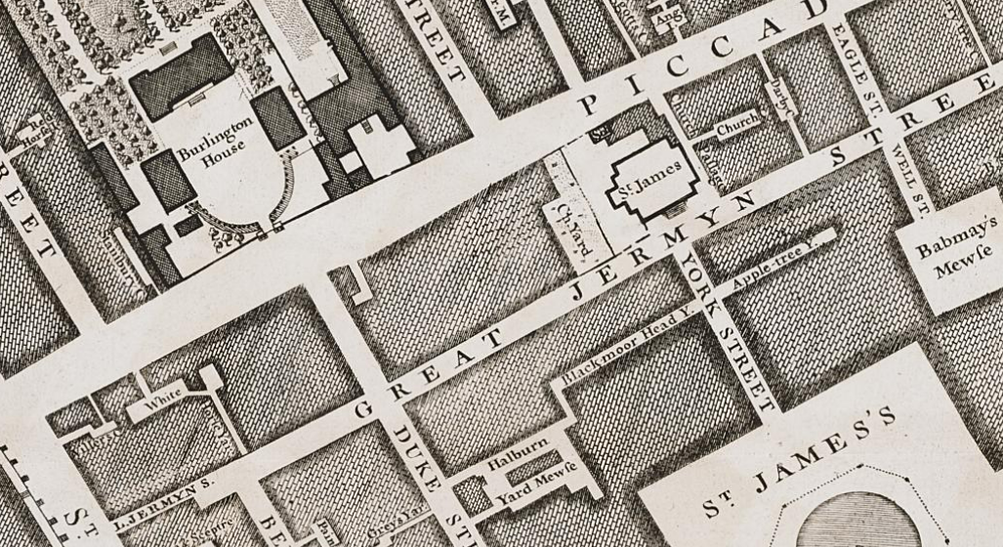
In 1762 he took the lease of a property at the rear of 171, Piccadilly once known as the White Horse Inn with stables attached. The property was actually in the ownership of the Crown. He clearly ran it as an inn for a very short time as well as his upholstery business. A London Directory of 1780 describes James Mackay as an upholsterer at 171, Piccadilly and a further Lease of 1784 mentions the White Horse Yard but not the Inn, which must have been de licensed and turned into a private house by then.

James died in February 1795 and by 1805 the property, with a frontage of 167ft, had come into the possession of his son John Mackay, described as an oilman i.e dealer in whale and vegetable oils, waxes, candles and even some types of paints, all much in demand before the discovery of natural oil and petroleum. John requested an extension to the Lease to enable him to rebuild part of the premises. The house by this time had been divided into 2 units and the stables were in public use. It was recommended by the Crown Agents that the site should be cleared and six dwelling houses erected. John appears to have agreed to this and in 1806 the lease was extended to 99 years. However it seems that it was some time before rebuilding could begin and in 1810 Mackay had to make a new application. Ultimately the fabulous and now historic display and exhibition hall, known as the Egyptian Hall, was erected on the frontage.

What this means of course is that James had become a very, very wealthy man with the right contacts and also that through the arrangements he had made in the various Leases and in his Will, his son John had also inherited rather well.
Interestingly neither wife Betty, nor his older sons James and Richard are mentioned in the Will dated 5th July 1793, suggesting that they had all predeceased him, but it is worthy of note that in this document, James had also made more than adequate provision for his daughters, Elizabeth, Margaret and Jane.
There will be more about John later.
As for the other children.
James Mackay born 29th. May 1757. Little has been found about him and it is assumed that he worked for either his grandfather or his father. A James Mackay died aged 22 in London on 18th. June 1779. He was buried in St. Margarets, Westminster. This could well be him especially taking into account that he is not mentioned in the later Will of his father.
Elizabeth Mackay born London 9th March 1759. Elizabeth married Major General Dugald Campbell of the East India Company Army at Fort St. George, Madras, India on 31st July 1777. They had 9 children, 7 boys and 2 girls.
James, Donald, Dugald, William, John, Margaret, Archibald Henry, Elizabeth and Charles.
After an illustrious army career son James became Major General Sir James Campbell, Donald died in infancy, Dugald joined 88th Regiment of Foot and died in Ceylon, William joined the 3rd Madras Cavalry, John the 1st Madras Cavalry, Archibald Henry went to sea and became Captain of the ship Duke of York in the East India Company fleet and died at sea off St. Helena in December 1824, on a return journey from China.
After his army career with the 94th Regiment of Foot, Charles retired and came to live at Ravensden with his Uncle and then after his death, with his Aunt Jane and her family in Bath.
One particularly interesting aspect of the life of Major General Dugald Campbell is that much of the correspondence between him and his employers the East India Company, and also Lord Wellesley, Governor General of Bengal remains extant and can be read.
Elizabeth died in Edinburgh on 2nd April 1801 aged 42 and her husband at Portsea Portsmouth on 10th. September 1809.
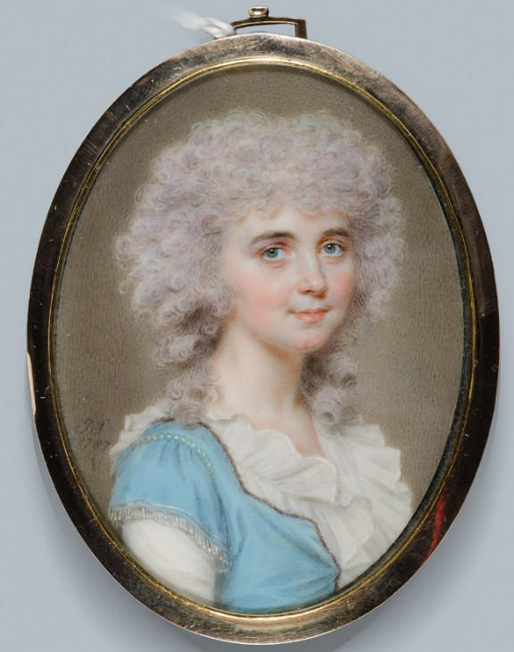
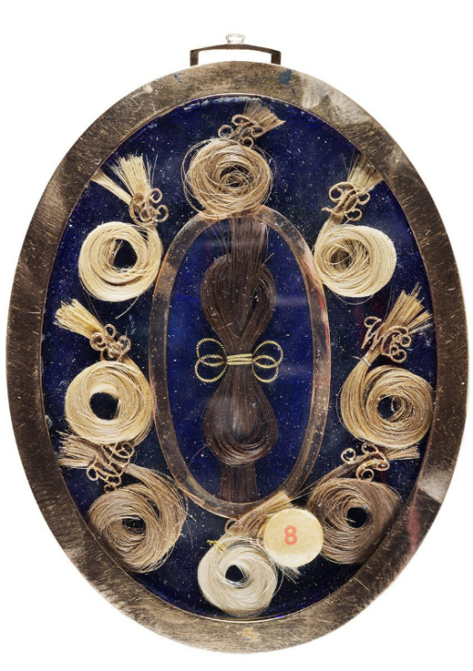
This portrait of Elizabeth is in the National Gallery of Canada and has a lock of the hair of each of the children attached to the reverse of the mount.

Courtesy: National Gallery of Canada.
https://www.gallery.ca/magazine/your-collection/a-miniature-portrait-of-elizabeth-campbell-by-john-smart}.
Richard Mackay born 29th October 1760 in London. Little is known about Richard except that he died in February 1790 aged 29 and was buried at St. James’s Piccadilly, {St James Gardens}.
Margaret Mackay born 5th. January 1763 in London. She married John Home of Bassendean, near Berwick. The marriage took place at Fort St George, Madras, India in either 1784 or 1785. Their first child a daughter Mary, was baptised at Fort St. George on 17th April 1786. John Home was a Captain in the army of the East India Company and of a junior branch of the very ancient Hume family so prominent in Scottish history. He was the youngest son of Rev William Home the Vicar of a village named Fogo also near Berwick. One of John’s brothers became Admiral Home, another Colonel of the 42nd Regiment, and another Captain of the 16th Foot. Two became clergymen.
Although he was the ninth child, by weird twist of fate John inherited the Bassendean estate, in 1789 but only lived there until his own death about 8 years later.
After their return to Scotland, {thought to be 1788} John and Margaret were in 1797 to have a son, almost ten years after his sister. He finally took the name John Home – Home so as to distinguish himself from his father John. Home-Home too went on to have a full military career with the 56th Regiment of Foot and as Commanding Officer of the Grenadier Guards. He was also Lieut. Governor of Nova Scotia.
He inherited Bassendean from his father when he died, but as he had never married and had no children the estate then passed to the son of his sister Mary.
Margaret {Mackay} Home herself died in Edinburgh in January 1806 and is interred in the churchyard of Greyfriars Church.
Her daughter Mary married at St. Andrews Church, Edinburgh in October 1806 and the Register entry reads ‘’Mary the daughter of the deceased John Home Esq of Bassendean’’ so although the date of the death of John has not been found it has to have been between 1797, when his son was born and 1806 when his daughter married.
Jane Mackay born 15th. May 1768 in London. She married Captain Webster Whistler of the 24th Regiment of Light Dragoons by special licence at St. George’s, Hanover Square on 18th October 1800. Webster was from the well known family of Whistler of Fairlight, Hastings and Battle. His father was Vicar of Hastings. Captain Whistler died at Kensington, London on 8th September 1837. They had five children, all born in London, three sons who served in the army in India, and two daughters. Of the daughters Ann was born 1811 {some records say 1797} and Eliza born 1816 {some records say 1821}. Ann was engaged to her cousin Archibald Henry Campbell {one of sister Elizabeth’s sons} the sea captain, but due to his death at sea the wedding never took place. On Webster’s death, Jane and her two daughters joined her brother John Mackay and Charles Campbell at Ravensden House where they remained until Mackay himself died. They then moved with Campbell firstly to Teignmouth, Devon and then Pulteney, Street, Bath. Each later died in Bath, Jane in May 1860, Ann February 1868, Eliza on Christmas Day 1857, and Charles Campbell in April 1852, and are buried side by side in the grounds of Bath Abbey.
John Mackay born 26th December 1769 in London. The youngest of the children. With his brothers dead and his sisters either married or betrothed and also well provided for in the Will of their father, John Mackay as the surviving son inherited considerable wealth which allowed him to pursue a military career as well as to later purchase the Ravensden estate and construct the house.
John clearly having been involved in the land transactions of his father and no doubt also his upholstery business, then became an oil man in his own right.
At some stage, while he was still party to the Piccadilly leases, he seems to have joined the army, firstly the Renfrewshire Militia, which had been founded as a home defence regiment in 1793. In 1803 it became the Argyllshire Militia, 1855 the Prince of Wales Royal Regiment of Militia, and in 1856 a battalion of the Argyll and Sutherland Highlanders, until being finally disbanded in August 1878.

In the early 1800’s the Argyllshire Militia were based both on the south coast between Dover and Margate protecting the coastline from possible invasion by Napoleon but also in Ireland. They were located at Pevensey Barracks in Sussex for several years and then in London guarding the Bank of England, followed by a further period in Ireland.
Sometime just after 1815, when he was known to have been in Ireland with the regiment, he retired and having ‘’given up’’ on London, in 1818, Mackay purchased the estate in Ravensden which then consisted of, on the west the land on both sides of the unsurfaced road from Ravensden to Thurleigh and to the south up to the road from Bedford to Kimbolton. There was a farmhouse close by known as Brook Farm but this was not included in the acquisition at that time and was also far enough away to not interfere with Mackay’s own plans for a large new house surrounded by ornamental parkland and to be known as ‘’Ravensden Park’’.
{Brook Farm was eventually purchased by the Wythes in 1881 and remains part of the current estate}
For whatever reason Mackay’s plans were never fully completed, the house was built but the parkland never laid out. Possibly the adoption of the road that ran through the estate made Mackay reconsider {it is known that he was opposed to this being surfaced and adopted}, or perhaps by then despite his investments {both he and Campbel were known to have had considerable capital in the East India Company}, sufficient finance was simply not available to complete the work.
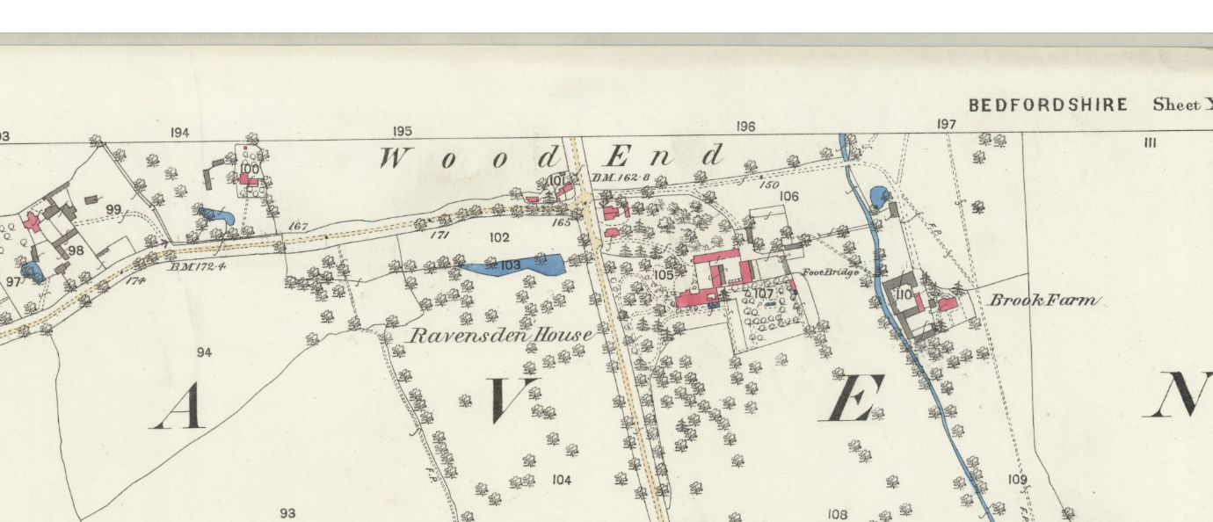

While he was at Ravensden John Mackay, who referred to himself as being a Colonel in the Argyllshire Militia, became something of a local figurehead. He served as Churchwarden, Overseer of the Poor and was unsuccessfully nominated for the office of High Sheriff of Bedfordshire in 1824.

He kept a fully operational farm {Traylesfield}, invested in one of the early brickyards that had opened in the village and together with Campbell they built the row of cottages on Bedford Road, Ravensden, that became known as ‘’Campbelltown,’’ and which are still standing but now barely recognisable.

Having then also been joined by his sister, the 1841 Census for Ravensden shows:-

1 | Wood End | MacKay | John | 65 | Ind | N
 |  | Campbell | Charles | 45 | Ind | Scotland
 |  | Whistler | Jane | 60 | Ind | N
 |  | Whistler | Ann | 30 |  | N
 |  | Whistler | Eliza | 25 |  | N
 |  | Lee | Elizabeth | 35 | F S | N
 |  | Headland | Mary | 20 | F S | N
 |  | Gascoine | Thomas | 20 | M S | Y
 |  | Braizer | John | 15 | M S | Y
 |  | Mc Dowell | John | 20 | M S | Scotland

When John Mackay died at Ravensden House on 28th February 1849 he was 77 years of age, his death was reported by John Brazier who stated that he had worked for him for ten years. Mackay had appointed his nephews Charles Campbell and John Home - Home as the Executors of his estate and in his Will dated 19th December 1843 Mackay left everything to them equally. Campbell sold his share to Home -Home who then promptly put the house, the contents , and the land {141 acres} and livestock, up for sale by auction commencing 9th April 1849. The complete sale took three days.
Although his death was recorded as being at Ravensden House, he was not buried in the village, and mysteriously to date, nothing has been found to indicate where this actually took place. It could possibly have been at St. James’s with his parents or maybe somewhere in Scotland.
Most remarkably though - within 41 days of John’s death, everything was being sold, especially as today it can take many months, even years.

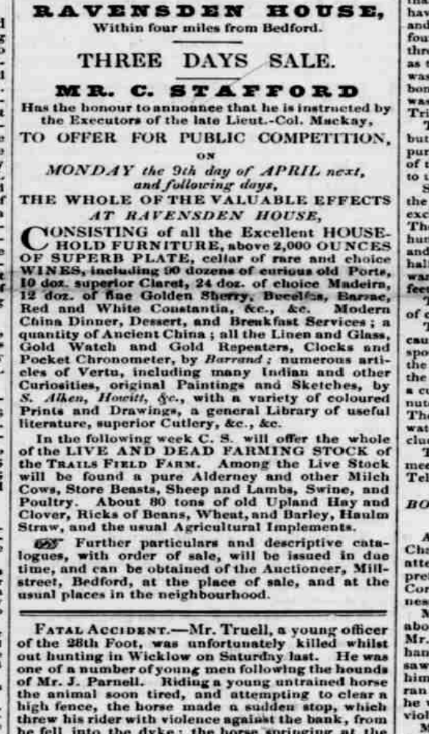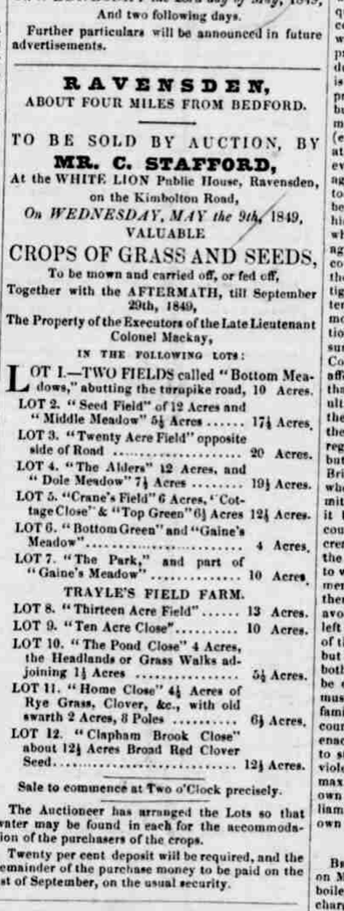
{Note the number of bottles in the wine cellar, 90 dozen curious Old Ports - 90 dozen that's over 1,000 bottles, 120 superior Clarets, nearly 300 choice Madeiras, 144 fine golden Sherries, plus the items of silver}.
By the end of the year the house and land had been fully acquired and occupied by Francis Wythes a railway contractor and the furniture and contents of the house dispersed. Jane, Ann and Emma Whistler, plus Charles Campbell had moved south, eventually settling in Bath.
And thus after 31 years began another chapter in the life of Ravensden House !
Special Thanks To: Angus Mackay in Canada and the Borders Family History Society.
March 2026.

